Sunshine Prevention Center E-Workbook

**User Manual**

**1-1) Main page**

* Main page has two buttons, Start and About as below.
* "About" page is for showing how to use this book
* User can start the E-workbook by clicking “Start” button.
* All the data user input while solving questions will be deleted when they exit the application.

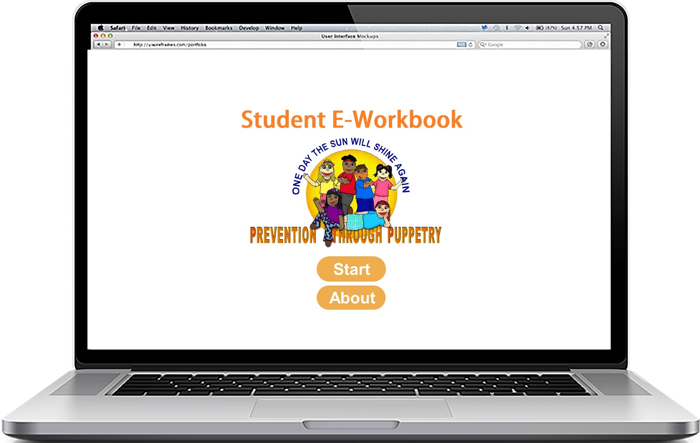

**1-2) About page**

* "About" page is for showing how to use this book
* If you click "Main Page" button, returns to Main Page

**2) Common pages information**

* Jump to any page is available by clicking on the corresponding number at the top of the page.
* On every page except page 1 and 10, users can continue on to next page by clicking “Next page” button. And also go back to previous page by clicking "Previous" button.
* On page 1 and 10, users can go back to Main page by clicking “Main Page” button.
* 1, 2, 5, 6, and 8 pages contain “Hint Button.”
* On click of "Hint Button," a dialogue giving a hint pops up as below. This dialogue will be useful solving the questions on each page.

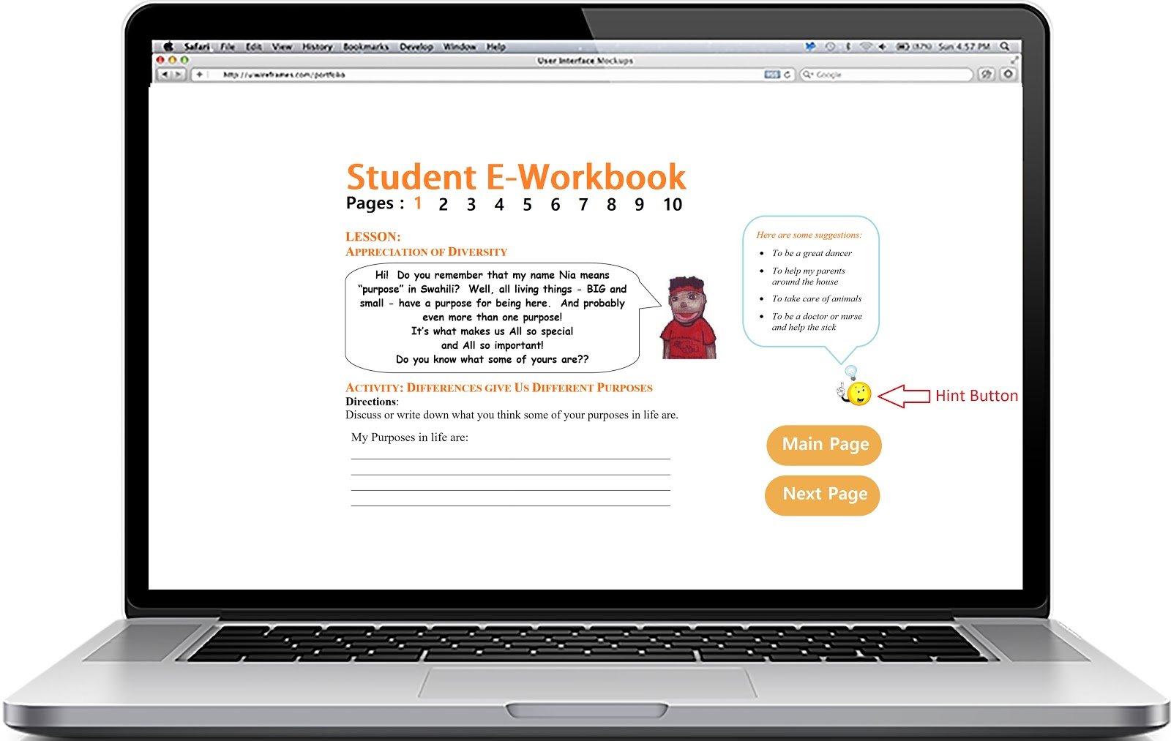

**2-1) Page 1**

* Page 1 is the section where users can discuss and write down what they think some of their purposes in lives are.
* Users can write their responses in the answer box at the bottom of the page.

**2-2) Page 2 ~ Page 4**

* Page 2, 3, and 4 are for understanding and expressing emotions.
* On page 2, Students can discuss about each feeling at the bottom by following the directions and hint dialogue.
* On page 3, students can draw the face of the flower on the images. This page provides the great chance to review the feeling garden chart after the discussion from page2.
* On this page4, students can write the answers in each cell of the table as below. This page are further advanced activities after understanding the feeling garden chart through activities on page 2 and 3.

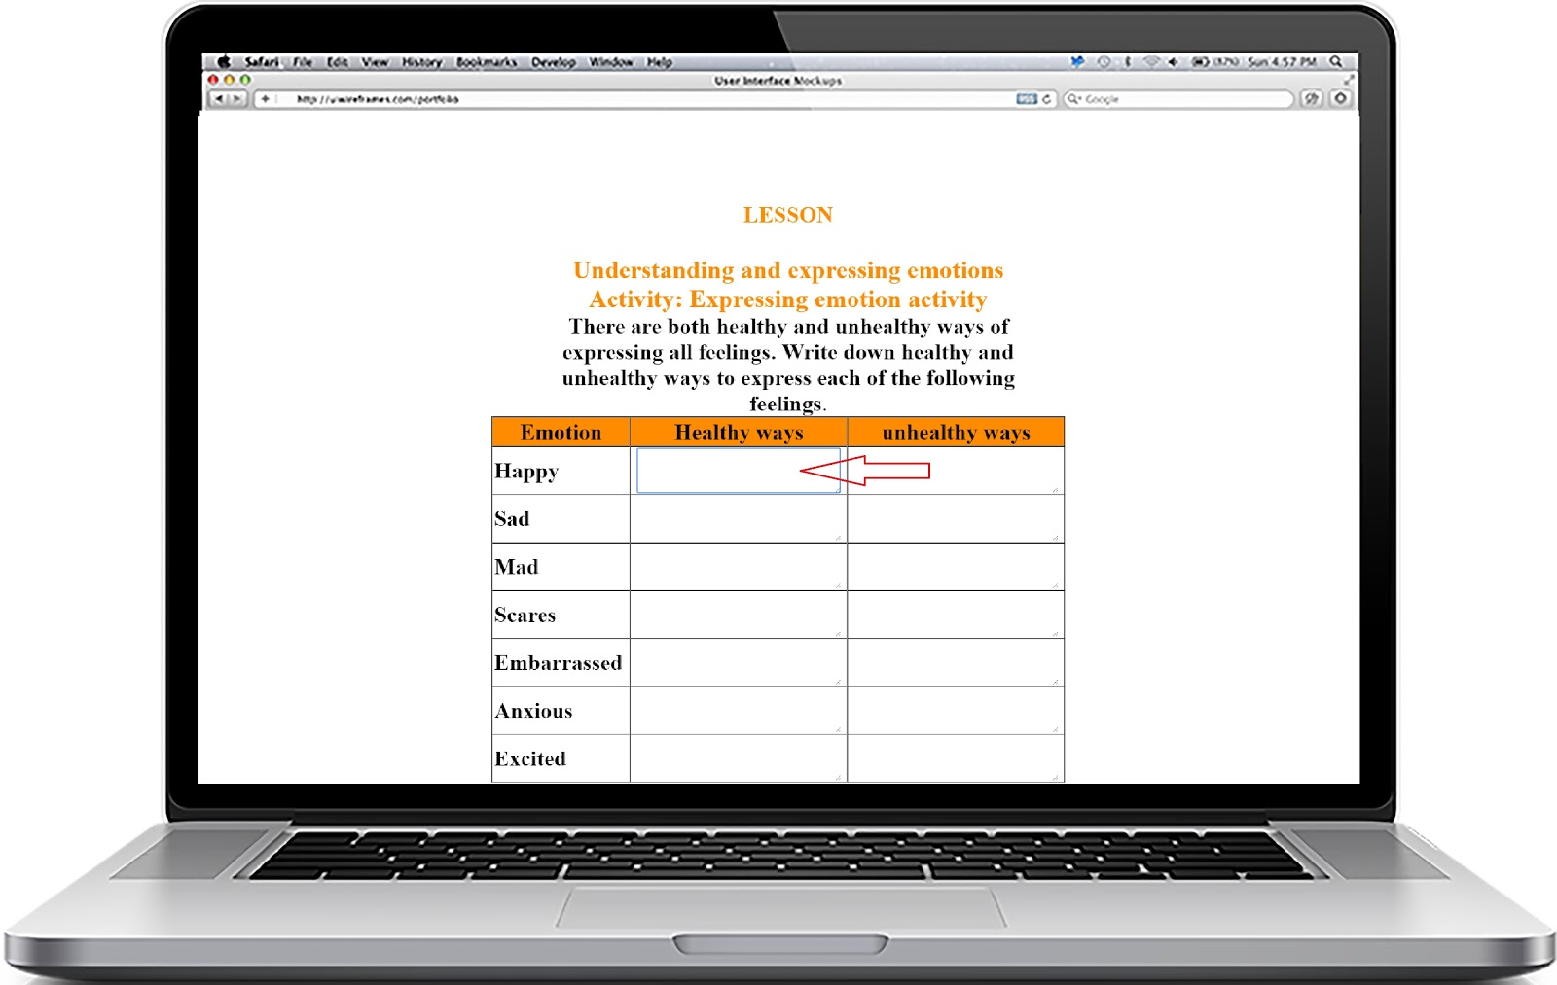

**2-3) Page 5**

* Page 5 provides the activity to learn the Sunshine Steps.
* Students can find the right order of the Sunshine Steps through the activity.
* Students can drag and drop each Sunshine Step below to the right location. If they get the right answer, Application will pop up the sign that they find the correct answer.

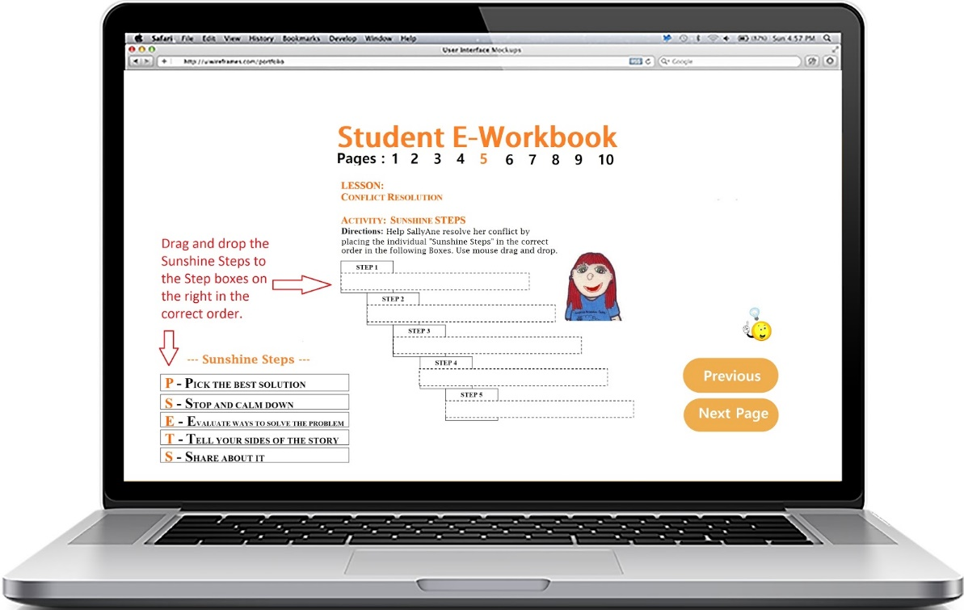

**2-4) Page 6**

* Page 6 provides the activity to learn how to deal with a Bully.
* When all of the correct answers as selected, a E-workbook will let you know that you get the right answer.
* Left click will make a circle and right click will cross off on each choice as below

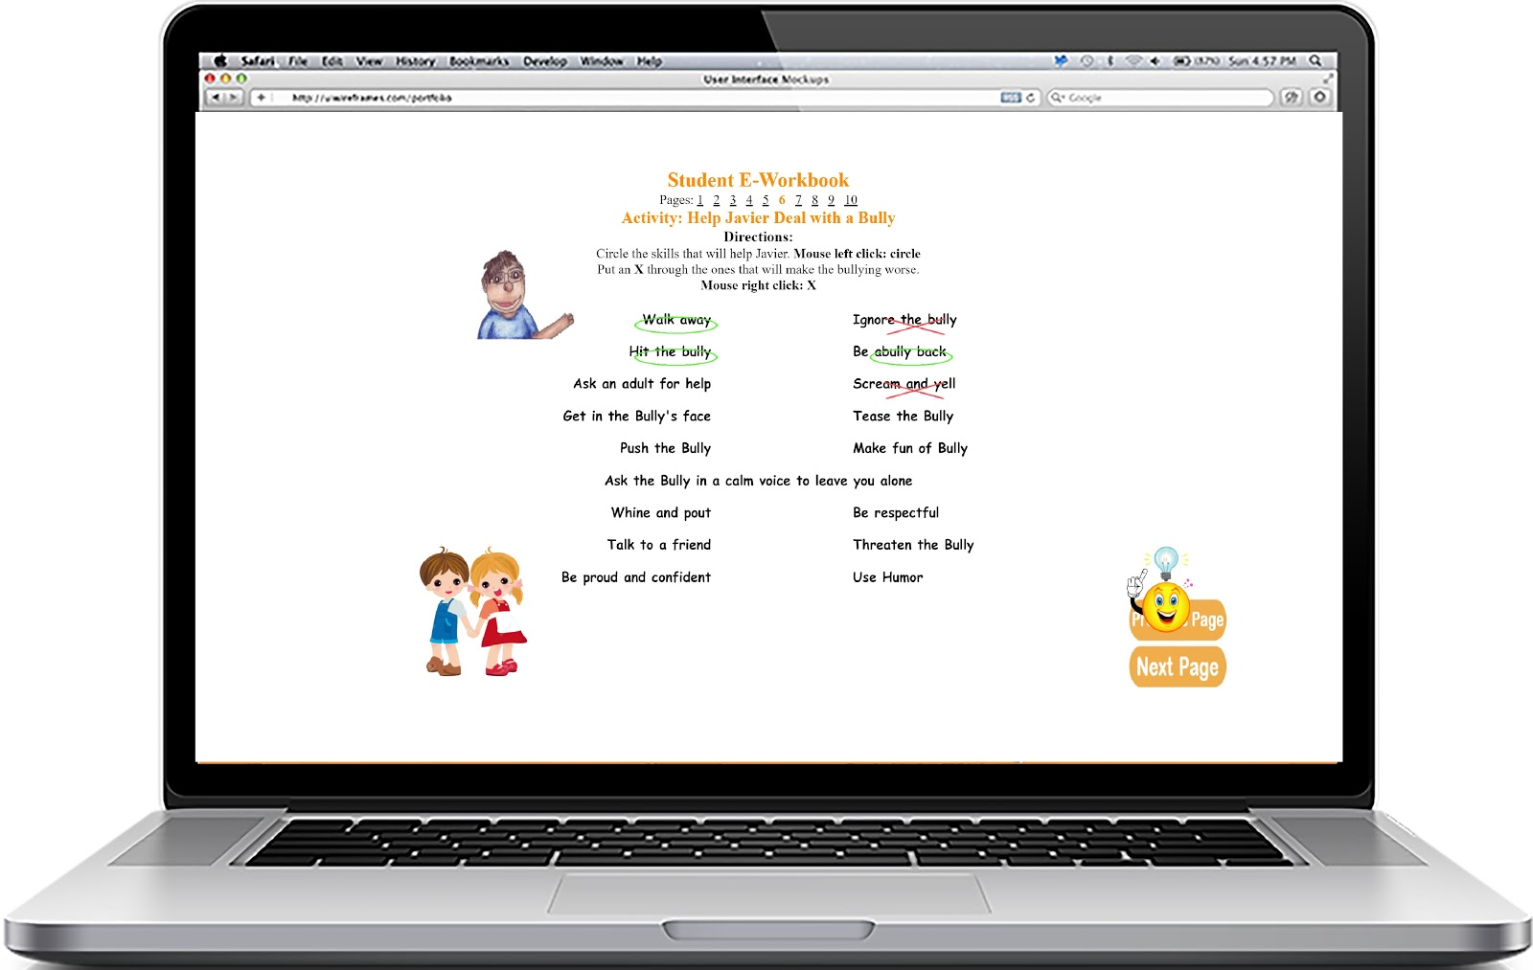

**2-5) Page 7, 9**

* Page 7 provides many questions which are good sources for learning what is being good friends.
* Further discuss and review with the class and teacher will be helpful for the page 7.
* Page 9 provides Sunshine Steps for being a good friend.

**2-6) Page 8**

* Page 8 provides the activity to learn what is the difference between to become a good friend and to become a bad friend.
* When all of the correct answers as selected, a E-workbook will let you know that you get the right answer.
* Left click will make a smiley face which means being a good friend.
* Right click will draw a sad face which means not being a good friend. 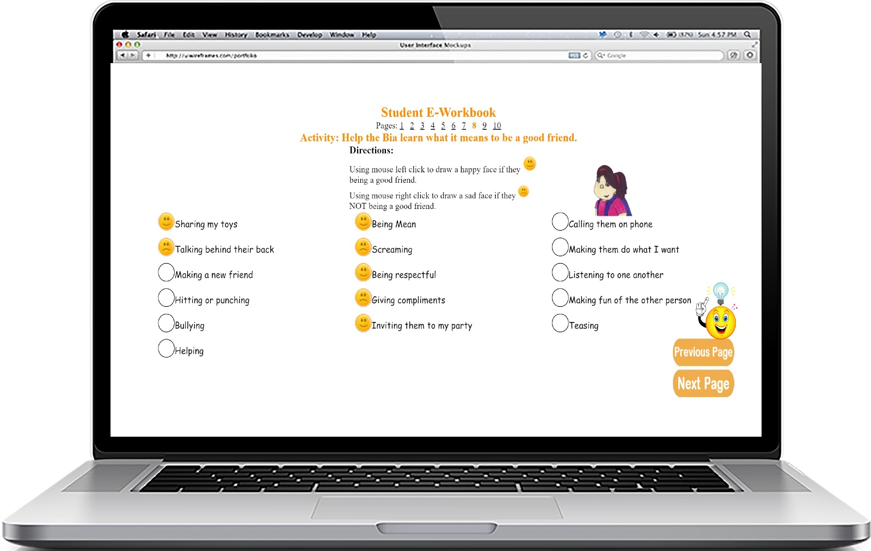

**2-7) Page 10**

* Page 10 provides the contact information and user can go back to main page by clicking “Main page” button. Every data that users have input so far will be deleted when they exit this page.

If you have any question, feel free to contact the development team

followyourinnercompass@gmail.com